The Revolution is Just Beginning
1.1 E-Commerce: The Revolution is Just Beginning
- What is e-commerce?
E-commerce is the use of the internet, the world wide web (www), and mobile apps to transact business. Although the terms internet and web are often used interchangeably, they are actually two very different things. The internet is a worldwide network of computer networks, and the web is one of the internet’s most popular services, providing access to billions of web pages.

- The Difference Between E-commerce and E-business
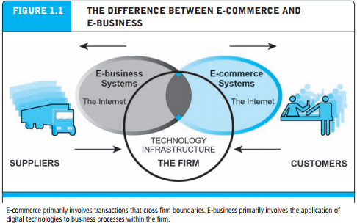

- 8 Unique Features of E-commerce Technology
- Ubiquity - Interactivity
- Global Reach - Information Destiny
- Universal Standards - Personalization/Customization
- Richness - Social Technology

- Web 2.0: Play My Version
Many of the unique features of e-commerce technology and the internet come together in a set of applications and social media technologies referred to as Web 2.0. The Internet started out as a simple network to support e-mail and file transfers among remote computers. The Web started out as a way to use the Internet to display simple pages and allow the user to navigate among the pages by linking them together electronically.
Let’s take a quick look at some examples of Web 2.0 applications and sites:
- Twitter
- YouTube
- Instagram
- Wikipedia
- Tumblr

- Types of E-commerce:
- Business-to-Consumer (B2C) E-commerce
- Business-to-Business (B2B E-commerce
- Consumer-to-Consumer (C2C) E-commerce
- Social E-commerce
- M-commerce (Mobile E-commerce)
- Local E-commerce

- Growth of the Internet, Web, and Mobile Platform
The Internet is a worldwide network of computer networks built on common standards. Created in the late 1960s to connect a small number of mainframe computers and their users, the Internet has since grown into the world’s largest network.
The World Wide Web (the Web) is one of the most popular services that runs on the Internet infrastructure. The Web was the original “killer app” that made the Internet commercially interesting and extraordinarily popular. The Web was developed in the early 1990s and hence is of much more recent vintage than the Internet.
The Mobile Platform provides the ability to access the Internet from a variety of mobile devices such as smartphones, tablets, and other ultra-lightweight laptop computers via wireless networks or cell phone service.

1.2 E-commerce: a Brief History
- E-commerce 1995–2000: Invention
- E-commerce 2001–2006: Consolidation
- E-commerce 2007—Present: Reinvention
- Assessing E-commerce: Successes, Surprises, and Failures
- Predictions for the Future: More Surprises

1.3 Understanding E-commerce: Organizing Themes
- Technology: Infrastructure
The development and mastery of digital computing and communications technology is at the heart of the newly emerging global digital economy we call e-commerce.

- Business: Basic Concepts
While technology provides the infrastructure, it is the business applications—the potential for extraordinary returns on investment—that create the interest and excitement in e-commerce. New technologies present businesses and entrepreneurs with new ways of organizing production and transacting business.

- Society: Taming the Juggernaut
With more than 243 million Americans now using the Internet, many for e-commerce purposes, and more than 2.5 billion users worldwide, the impact of the Internet and e-commerce on society is significant and global. Increasingly, e-commerce is subject to the laws of nations and global entities.

